EXPERIMENT 3

HOBBY APP

AIM

TO DESIGN A HOBBY APP

PROCEDURE

* Select the number of wireframes according to the need
* Create a login page in the very first wireframe
* Decide the number of hobbies for eg(4)
* Select the categories (singing,dancing,cooking,reading)
* Have the description for every category in separate wireframes
* Finally have a end page which boosts to make hobby as career

SCREENSHOT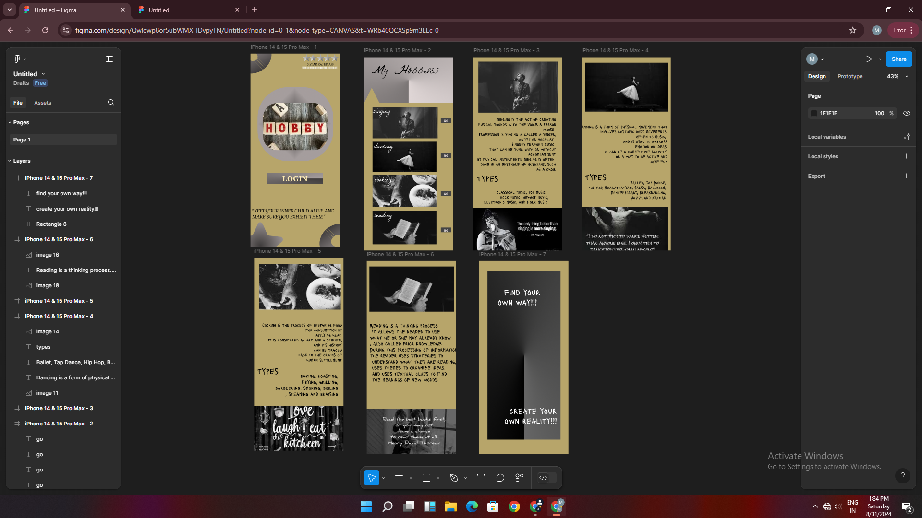

RESULT

A Hobby app is designed